**Blinkit Sales Analysis Dashboard (2011–2022)**

About the Project:

This project analyses 11 years of grocery sales data from Blinkit, a leading instant delivery app in India. Using Power BI, an interactive dashboard was built to track sales trends, item types, outlet performance, and customer preferences. Python (with Pandas, Matplotlib, and Seaborn) was used to validate insights and visualize sales by item category. The goal was to derive actionable business intelligence from raw data to help optimize product strategies and improve outlet performance.

**📊 Blinkit Grocery Sales Analysis (2011–2022)**

This project presents a comprehensive sales analysis of Blinkit, India’s last-minute grocery delivery app, using Power BI and Python (Matplotlib & Seaborn).

**🔷 Power BI Dashboard Insights:**

* **Total Sales**: $1.20M
* **Average Sales per Item**: $141
* **Average Customer Rating**: 3.9
* 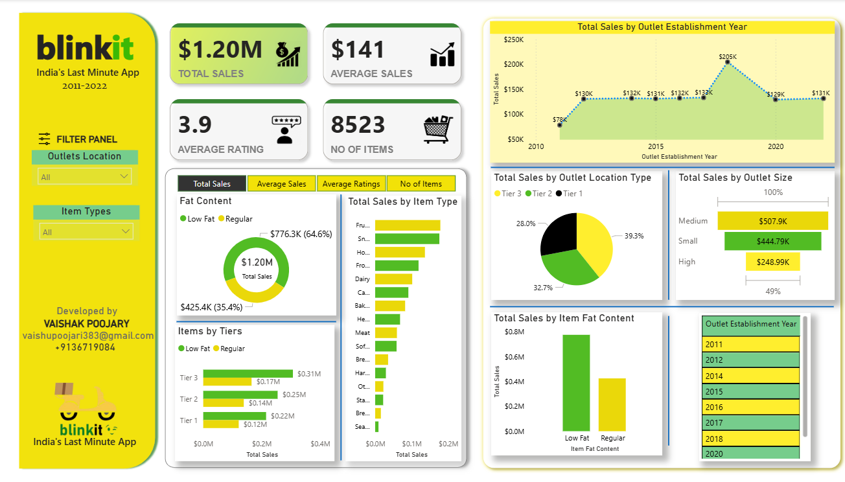**Total Items Analyzed**: 8,523

**Key Visualizations:**

* **Total Sales by Item Type**:
  + Highest sales from **Fruits & Vegetables**, followed by **Snack Foods** and **Household** items.
* **Sales by Fat Content**:
  + Low Fat: $776.3K (64.6%)
  + Regular: $425.4K (35.4%)
* **Sales by Outlet Type**:
  + Tier 3: 39.3%, Tier 2: 32.7%, Tier 1: 28%
* **Sales by Outlet Size**:
  + Medium: $507.9K, Small: $444.79K, High: $248.99K
* **Sales by Outlet Establishment Year**:
  + Peak in **2018** with $205K

**🐍 Python Visualization:**

Using pandas, matplotlib, and seaborn, a bar chart was created to display **Total Sales by Item Type**.

**Code Summary**:

* Dataset was cleaned and grouped by item type.
* 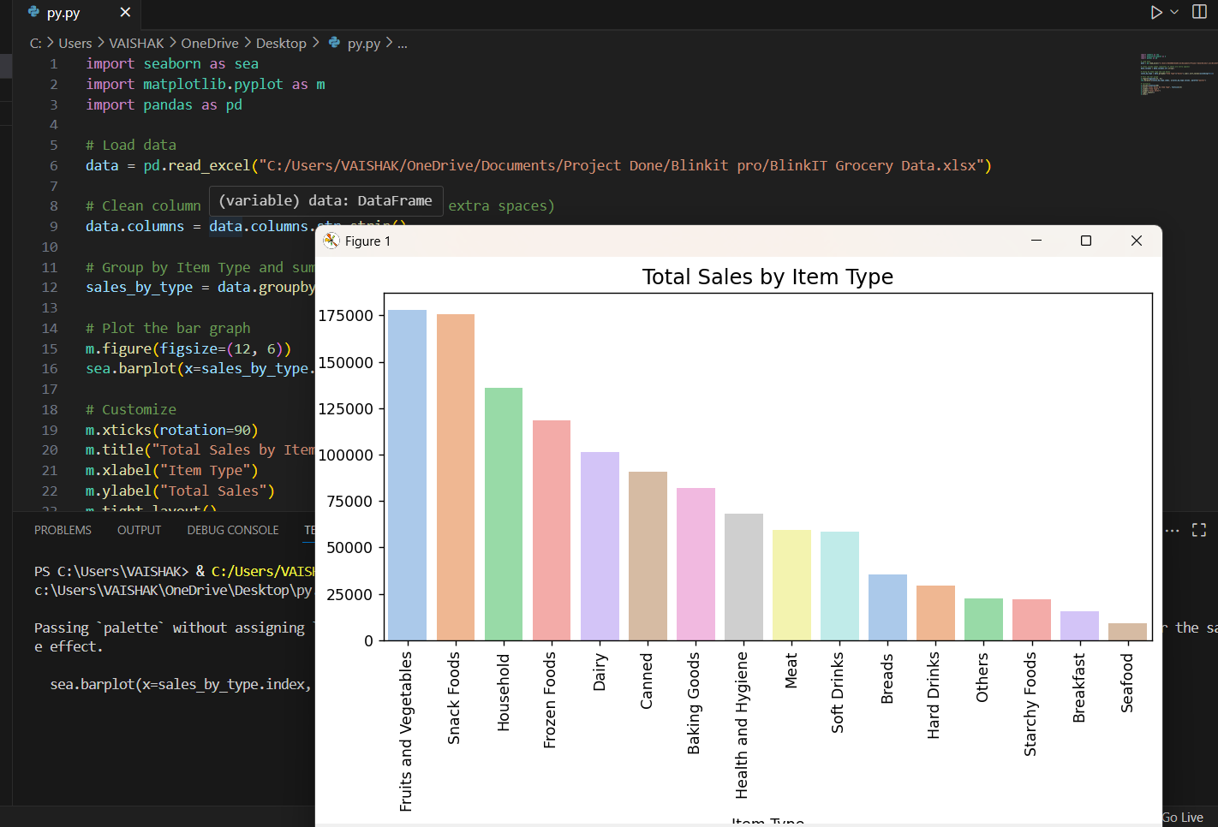A color-coded bar chart highlights top-performing categories.
* 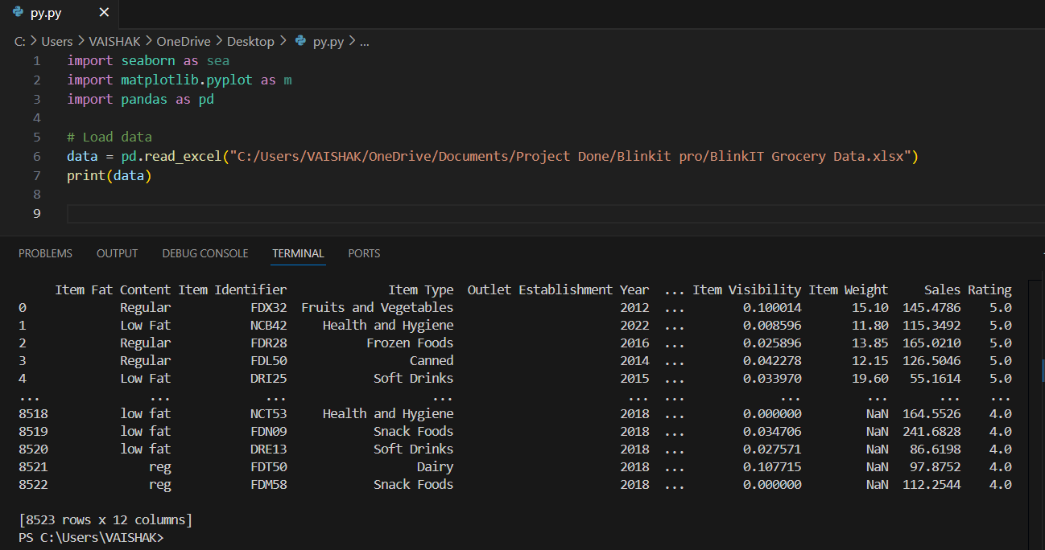Visualization confirms dashboard insights, emphasizing dominance of Fruits, Snacks, and Household items.

**📊 Business Intelligence (BI)**

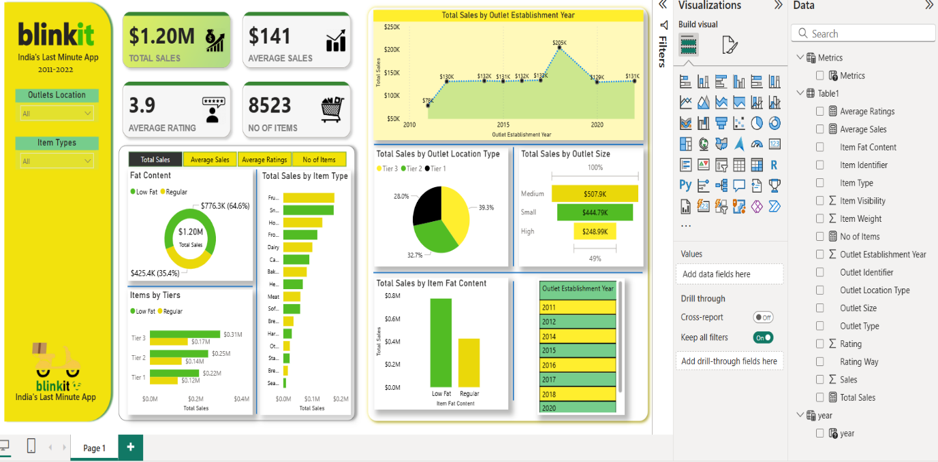The Power BI dashboard provides a comprehensive analysis of Blinkit's performance metrics between 2011 and 2022. It showcases key indicators such as **Total Sales ($1.20M)**, **Average Sales per item ($141)**, **Average Customer Rating (3.9)**, and a total of **8,523 listed items**. Using various filters like **Outlet Location**, **Item Type**, **Outlet Size**, and **Establishment Year**, users can explore the business data interactively.

Key visualizations include a **donut chart** showing sales by fat content (Low Fat vs Regular), **bar charts** highlighting top-selling item types (such as Snack Foods, Fruits, and Frozen Foods), and **pie charts** showing the distribution of sales by outlet tier (Tier 1, 2, and 3). The dashboard also illustrates trends in outlet performance over time, enabling stakeholders to track how different outlet sizes and years influenced total revenue. This dashboard was built to help Blinkit make informed decisions around product offerings, outlet investments, and customer preferences using business intelligence tools like Power BI.

**🐍 Python – Detailed Explanation:**

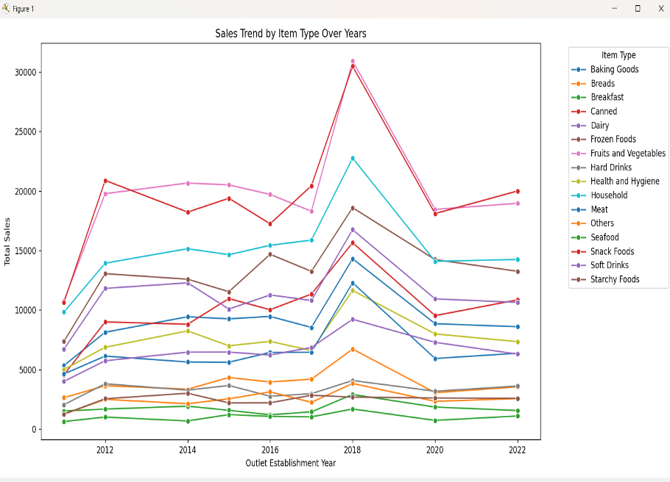Python was used to generate the **line graph of “Sales Trend by Item Type Over Years”**, visualizing how sales fluctuated across 20 different product categories like Snack Foods, Fruits and Vegetables, Household items, Dairy, and Meat. Libraries like **Matplotlib** and **Pandas** were likely used for this visualization and data processing.

By plotting the sales data year-wise, Python helped uncover important insights such as the significant spike in total sales during **2018**, where many categories peaked — especially Snack Foods and Fruits. The ability to visualize each category over time allows for better trend analysis, seasonal behavior detection, and inventory planning.

Python complements BI tools like Power BI by handling raw data processing, data cleaning, and advanced analytics. It plays a crucial role in preparing datasets for dashboards and allows analysts to run deeper statistical or predictive models on business performance. This combination of Python and BI creates a powerful ecosystem for real-time business intelligence and long-term strategic planning.

**Conclusion:** By combining the strengths of **Power BI** for visual storytelling and **Python** for data analysis, we were able to extract meaningful insights from Blinkit's sales data. Power BI helped present key metrics and patterns through interactive visuals, while Python enabled deeper trend analysis and historical comparisons across item categories. Together, these tools empowered data-driven decision-making for improving product strategy, customer satisfaction, and outlet performance. This project demonstrates the real-world impact of using modern data tools to turn raw numbers into actionable business intelligence.

**👤 Prepared By:**

**Vaishak Poojary  
📧 Email: vaishupoojari383@gmail.com  
📞 Phone: 9136719084  
🔗 LinkedIn:** [**linkedin.com/in/vaishak-poojary**](https://www.linkedin.com/in/vaishak-poojary/) **💻 GitHub:** [**github.com/VaishakPoojary**](https://github.com/VaishakPoojary)